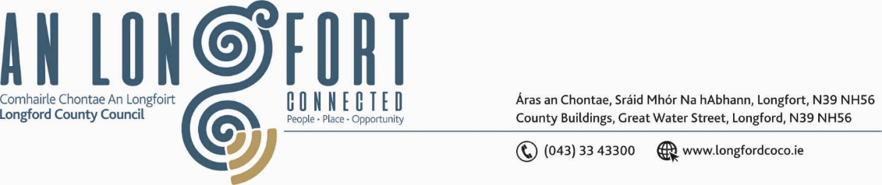

***BALLYMAHON MUNICIPAL DISTRICT***

***Please note meeting will be held via Microsoft Teams and in Ballymahon Library.***

**17 May 2022.**

**To: Each Member of Ballymahon Municipal District.**

**Dear Member,**

You are requested to attend a Meeting of Ballymahon Municipal District to be held

**in Ballymahon Library and via Microsoft Teams** on **Monday 23 May 2022 at 3.45pm** to transact business, as set out on the Agenda hereunder.

**Yours sincerely**,

Ann Marie Mc Keon

_______________

**Ann Marie Mc Keon,**

**Meetings Administrator.**

**AGENDA**

Prayer before meeting.

**1.** Confirmation of Minutes:

(i) Ballymahon Municipal District Meeting held on the 25 March 2022 – copy enclosed.

(ii) Ballymahon Municipal District Committee Meeting held on the 25 March 2022 – copy enclosed.

**2.** Matters arising from Minutes.

**3.** Declaration of Interest by Members.

**4.** Management Report - enclosed.

**5.** Presentation – ‘Strategic Housing Development application to an Bord Pleanala for 100 number residential units (50 number houses, 50 number apartments) and associated site works at Bloomfield Park, Bracklin Road, Edgeworthstown’

**6.** Polling Scheme Review.

**7.** Community Grant Support Scheme 2022 – enclosed.

**8.** Proposed Projects/Expression of interest.

**9. Notices of Motions, submitted by Councillors, as listed hereunder –**

**Councillor Gerard Farrell**

(i)“I call on Longford County Council to install a fast-charging point at the carpark in Lanesboro”.

(ii) “I call on Longford County Council to upgrade the old play area at the back of Church View in Lanesboro to a sensory garden”.

(iii) “I call on Longford County Council to provide additional parking spaces in front of the houses at Knock Manor Lanesboro and to address the drainage issue in the estate”.

**Cllr Pat O’Toole**

(i) “I call on Longford County Council in consultation with the National Transport Authority to consider providing 2 bus shelters at the bus stops located at Upper Main Street Ballymahon”.

(ii) “I call on Longford County Council to consider placing a weight restriction on trucks using the L1131 at Rathmore, Ballymahon (maybe 3 or 5 tonne) as this road is being used extensively as a bypass of Ballymahon Town and is not fit for the volume off heavy trucks and lorries using it”. If a restriction was to be placed on the road local landowners would be exempt as would trucks delivering home heating oil to farms and dwellings etc.

(iii) “I call on Longford County Council to provide speed ramps in the Creevaghbeg Estate off the Mullingar Road Ballymahon, in the interest of public safety and to reduce excessive speeding through the estate”.

**Councillor Paul Ross**

(i) That Longford County Council erect signage to clearly signal and promote the new free car park in Edgeworthstown behind the library.

(ii) “I call on Longford County Council to immediately prioritise the installation of the new streetscape in Edgeworthstown as the unfinished works with the lighting poles are dangerous to pedestrians and cars alike”.

(iii) “I call on Longford County Council to repaint the bus parking lines in Ballymahon town as the existing lines are now worn off and the road on main street be resurfaced as a matter of urgency”.